***CIS 311 – Assignment 3***

This program is going to require you to build a console application for a medical practice. Many times minimal interfaces will need to be constructed and a console application is the simplest way to handle this. Your system is going to prompt the user for an input file which contains the following record layout in tab delimited format: Patient ID, First Name, Last Name, Date of Visit to the Practice, and Disease Classification.

Your program should ensure the input file exists. If it doesn’t, display a message to the user and then exit the program -- do not keep prompting for another filename. If the file exists, your program will then perform processing on the file, keeping track of each unique disease in the file and how many times the disease was encountered. A total of the number of patients seen should be collected as well, along with the earliest visit date and the latest visit date of the group of patients in the file in so that a report can be constructed.

Once the data has been processed, you should prompt the user for the name of a file to write the report to. Again, ensure the path is valid; if it’s not, print a message and end. Once the report has been written out, prompt the user asking if he/she wants to see the report. If the user enters Y or y, the file should be displayed. Here’s a sample execution of the program and the report:

Please enter the path and name of the file to process:

C:\temp\diseases.txt

Processing Completed...

Please enter the path and name of the report file to generate:

C:\temp\report.txt

Report File Generation Completed...

Would you like to see the report file? [Y/n]

y

MuchoMedical Health Center

Disease Report for the Period ***earliest_date*** through ***latest_date***

There were a total of ***XX*** unique diseases observed.

A total of ***YYY*** patient encounters were held.

Relative Histogram of each disease:

Spastic Colonitis : 0014 ***********************

.

.

.

.

Chronic Phlegm : 0031 **************************************************

-------------------------------------------------------------------------------

Scale : 0***YYY*** 1 2 3

0 0 0

Notice that you need to have your program process the file to find the earliest date and latest dates to print on the second report title line. You also need to note how many unique diseases were observed along with the total number of patients that were seen.

Once you have the necessary total counts, you need to scale the data appropriately and print a histogram (graph) showing each disease and the number of times it was encountered during the date range. The values in the histogram are sorted in ascending order by the count of how many times each disease was observed. At the bottom of the histogram you should also have your program provide an appropriate scale. Notice that 31 was the highest observation of any particular disease, so I dropped to the nearest tens value and then had the program correctly space the tens values on the bottom of the chart.

Make sure that you don’t hard code anything regarding the scaling. In other words I should be able to input a different file with say 500 patients and 35 different diseases, and your program should handle it. Furthermore the scaling at the bottom of the histogram has to be dynamic as well, based on the actual data observed in a given data set…this is what the expectations are on real reporting software.

Finally, make sure you set the console up so that the background color is Blue and the text color is Yellow. Place an appropriate title on the console window and make sure you are using a non-proportional font so that your scaling all works out right. Have fun!

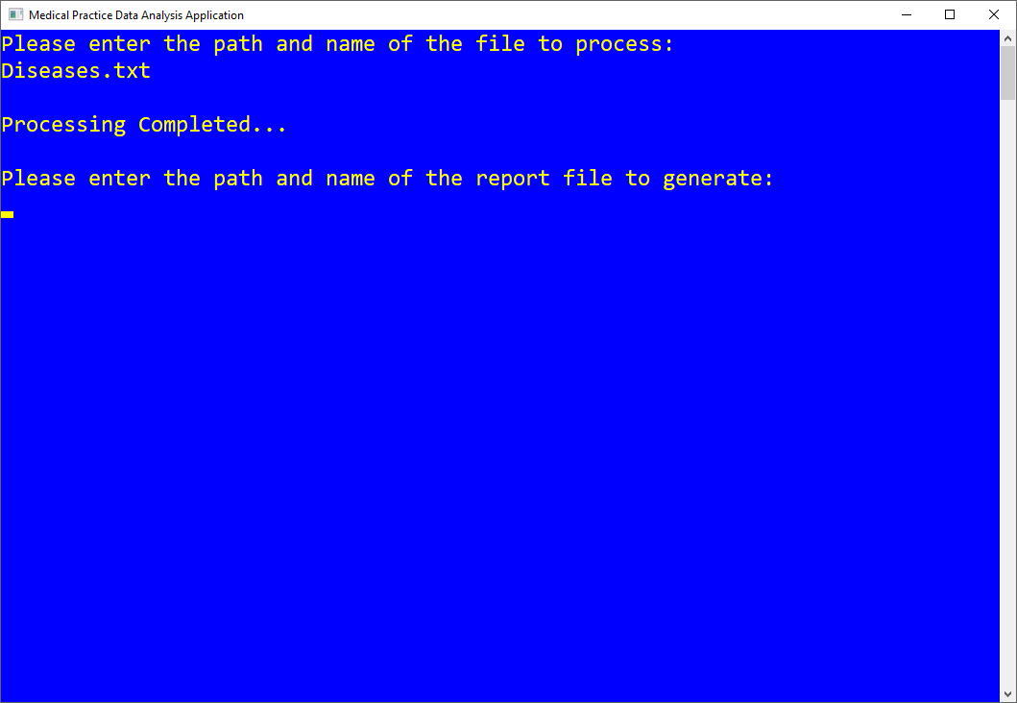

Complete your assignment and place your entire solution in a zip file, which you will upload to Canvas. Turn in a cover sheet and screenshots of your program’s execution stapled together in that order in class.